This weather has been shockingly pleasant here in Chicago this winter, and really throughout the United States. While the warm weather is continually tricking me into believing that spring is just around the corner, it’s certainly been a welcome surprise after the cold and snowy intensity of last year and the year before. Over the last few months, with the help of my personal climate scientist, John Dwyer, I’ve been learning a bit about the atmospheric patterns that lead to such different winter conditions, and how they can be used to predict short-term weather trends.

The main atmospheric phenomenon that affects our winter temperatures in the Northern US, as well as in Northern regions around the world, is known as the Arctic Oscillation (AO). The AO is an index of the pressure patterns in the Arctic. When the AO is negative, high pressure at the North Pole pushes the jet stream southward, allowing cold air to leave the Arctic and leading to very cold and snowy weather in Europe and the United States. This negative pattern has been compared to leaving the refrigerator door open: while it leads to very cold winters further south, winter in the arctic actually tends to be quite mild when the AO is negative.

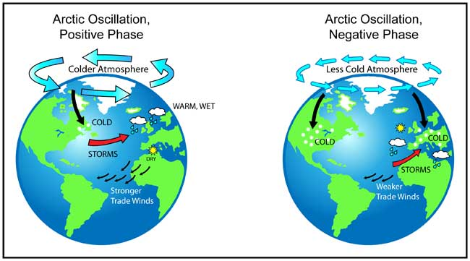

When the AO is positive, low pressure in the arctic region results in a very strong jet stream that is pushed to the north, creating a “gate” that keeps arctic air in the arctic and leads to warmer weather in Europe and the US. In areas like Greenland and Newfoundland, which remain above the jet stream, a positive AO is associated with colder weather.

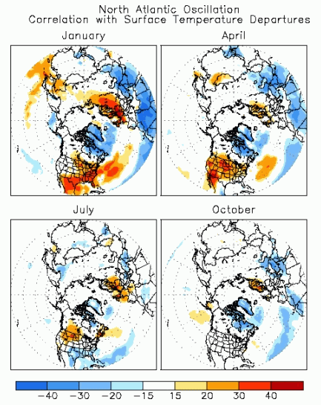The AO varies from one day to the next, and can go from very positive to very negative within a single season. It’s difficult to predict how positive or negative the AO will be more than a week or two in advance, but the state of the AO has a strong influence on temperature in the Northern hemisphere, especially during winter and spring. Because of this, the AO is sometimes considered the “wild card” of weather predictions in the winter.

The biggest contributor to the weather on a given day is seasonable variability: we can be pretty certain that it will be warmer in July than in January. Additionally, long-term atmospheric patterns like El Niño can be predicted months ahead of time, and can be used to make forecasts for the seasons ahead. The AO is much more difficult to predict, but it is the largest source of variability in temperature and precipitation patterns after seasonal variability, accounting for 20% of the variability in atmospheric pressure. In addition to the AO and other larger atmospheric patterns, local weather events like storms and fronts are also important for accurately predicting the weather. The illustration to the right shows the correlation between AO phase and temperature in the northern hemisphere at different points in the year.

Over the past few years, the arctic oscillation has exhibited extreme values both in the positive and negative direction. The winters of 2009-2010 and 2010-2011 were both marked by very negative AO, resulting in cold weather in much of the US and several memorable blizzards. The fall and winter of 2010 were marked by the most negative values of the AO that have been observed in the last 60 years.

This year we saw the opposite pattern: for most of the fall and winter, the AO was strongly positive. This means that throughout most of the Northern Hemisphere, we experienced a warm, mild fall and early winter. Then, around mid-January, the AO went negative. Here in Chicago we experienced colder weather and a couple of good snowfalls. In Europe, some areas experienced bitterly cold temperatures: the Dutch became hopeful that it would be cold enough to allow them to hold a 125 mile speed-skating race between eleven cities, known as “Elfstedentocht”. The event, first organized in 1909, is safe only when the ice in rivers and canals throughout the route is at least 6 inches thick: it has only been held 15 times and was last held in 1997.

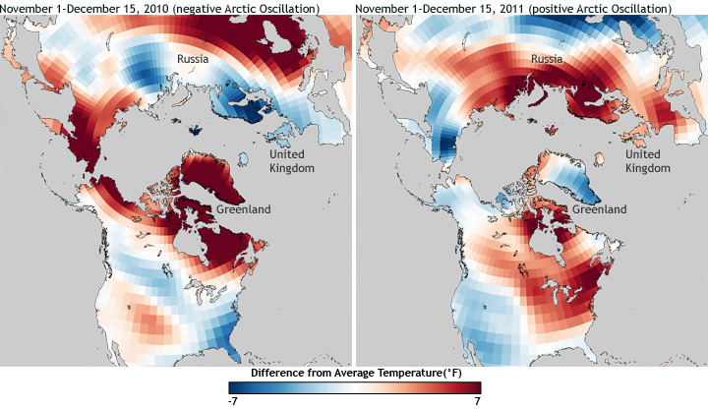

Unfortunately for Dutch speed skaters, but fortunately for the rest of us, the AO has slipped back into the positive over the last few days, and is forecasted to remain positive into March. Organizers of Elfstedentocht have called off plans to hold the event, and snowdrops are blooming in Chicago. Below is a chart of the observed arctic oscillation index from last October to the present:

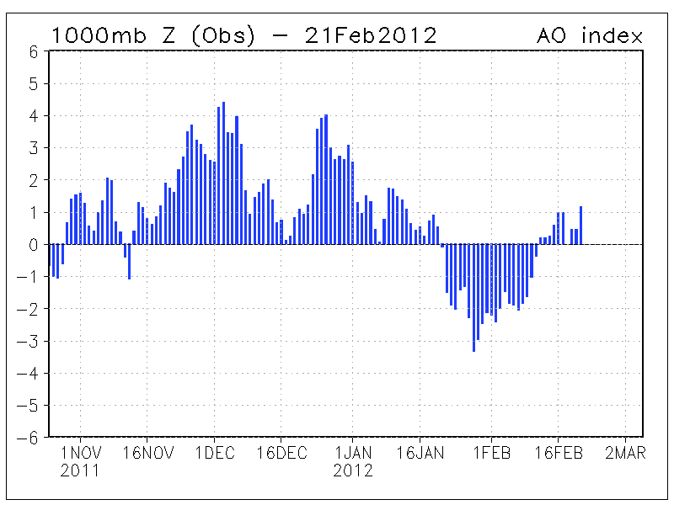

It’s not yet clear if the AO is being affected by global warming. From the 1960s to the 1990s, scientists observed a positive trend in the AO, but the AO values in the 2000s were not consistent with this trend. In fact, a New York Times article last year said that some scientists believed that the AO negativity of that year (and of 2009-2010) could be due in part to global warming. Scientists will most likely have to wait until more data comes in, perhaps for the next decade or longer, before they can conclude whether there is a persistent long-term trend in the AO that is related to global warming, or if the trend in the late 20th century was just random variability.

*Thanks to John for all his technical help with this topic. If you want more information, check out the links below:*

<http://www.cpc.ncep.noaa.gov/products/precip/CWlink/daily_ao_index/ao.shtml>

<http://www.climatewatch.noaa.gov/image/2011/so-far-arctic-oscillation-favoring-mild-winter-for-eastern-u-s>

<http://en.wikipedia.org/wiki/Arctic_oscillation>

<http://www.atmos.colostate.edu/ao/introduction.html>

<http://www.nytimes.com/2011/01/25/science/earth/25cold.html?_r=1&pagewanted=all>

*And for more about Dutch speed skating:*

<http://www.npr.org/blogs/thetwo-way/2012/02/10/146700851/historic-dutch-speed-skating-event-called-off-due-to-unsafe-ice>